Experiment No. # 10

**SYSTEM OF LINEAR EQUATIONS**

**Objective**

1. Be familiar with system of linear equations.
2. Solve system of linear equations using the various linear algebra techniques.
3. Solve system of equations using Python programming.

**Algorithm**

1. Type the main title of this activity as "System of Linear Equations”
2. On your GitHub, create a repository name Linear Algebra 58013
3. On your Colab, name your activity as Python Exercise 10.ipynb and save a copy to your GitHub repository

**Discussion**

Solving system of linear equations can be done using various techniques such as:

1. Gaussian Elimination
2. Gauss-Jordan Elimination
3. Cramer's Rule

For the lecture part of this laboratory activity you should be taught about how to do Gaussian Elimination and Gauss-Jordan Elimination. Cramer's Rule. So assuming the theory and manual approach in solving linear equations is out of the way, we'll try to solve them programmatically.

We can represent it in matrix form considering the linear combination of the equations. We can also think of its dot product form:

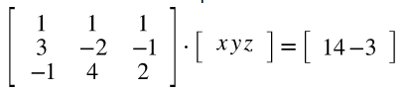

We can make a general form for this equation by putting our matrices and vectors as variables. So let's say that the matrix 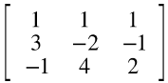 is X and

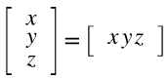 is the vector r then the answer 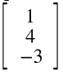 as Y

So we'll have:

X r = Y

Our goal is to solve for r so we can solve it algebraically by multiplying both sides with the inverse of X, so we'll get:



We'll take r = X -1Y as the vectorized equation as our formula in solving for the vector r or simply solving for x, y, and z. We can then code that as:

|  |
| --- |
| X = np.array([  [1,1,1],  [3,-2,-1],  [-1,4,2]  ], dtype=float)  Y = np.array([  [1],  [4],  [-3]  ],dtype=float)  print(X)  print(X.shape)  print(Y)  print(Y.shape) |

**Coding Activity 10**

So let's start off with an easy one. Let's say you have a bakery and you are purchasing supplies consisting of flour, yeast, and eggs from your supplier. For month 1 you bought a bakery promo that consists of 30 sacks of flour, 10 packs of yeast, and 120 eggs and you are charged for 12,500 pesos. For month two you bought a different bakery promo that consists of 40 sacks of flour, 20 packs of yeast, and 200 eggs then you are charged with 18,000 pesos. And then for month three you bought yet a different bakery promo that consists of 50 sacks of flour, 40 packs of yeast, and 360 eggs for 25,700 pesos. Now you are wondering if the promos are more cost-effective compared to buying them as a regular buyer, what could be the price of the flour per sack, yeast per pack, and one piece of egg?

Create a python program to solve for the price of flour per sack, yeast per pack, and one piece of egg.